Non-Collinear Points
# Source: AI Source: Provided by: [Data Path: Persons Table -> ID Column: 1, Name_En Column: Motasem Essam] -> From: [ChatGPT] on [7/25/2026]
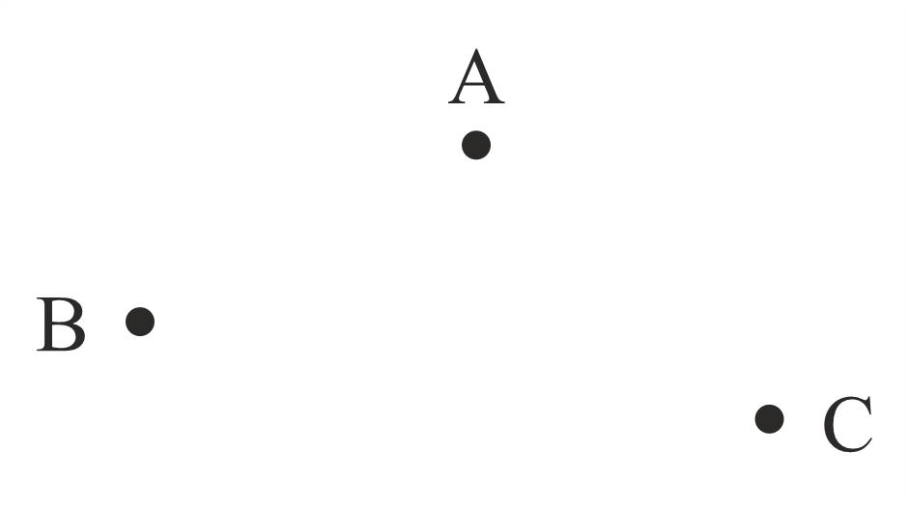
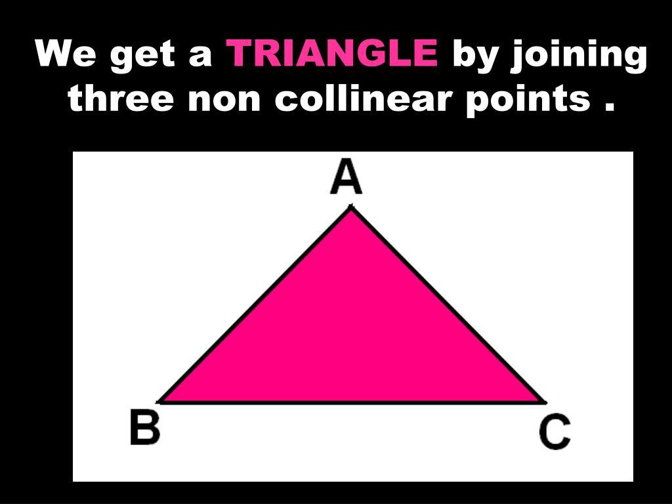
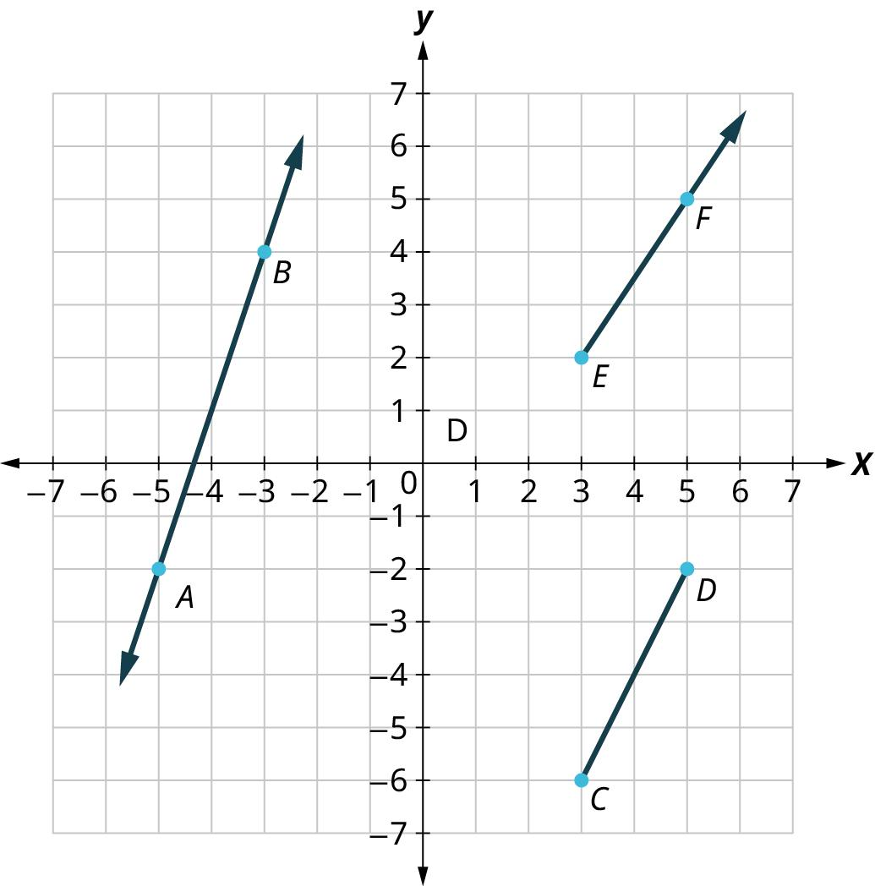
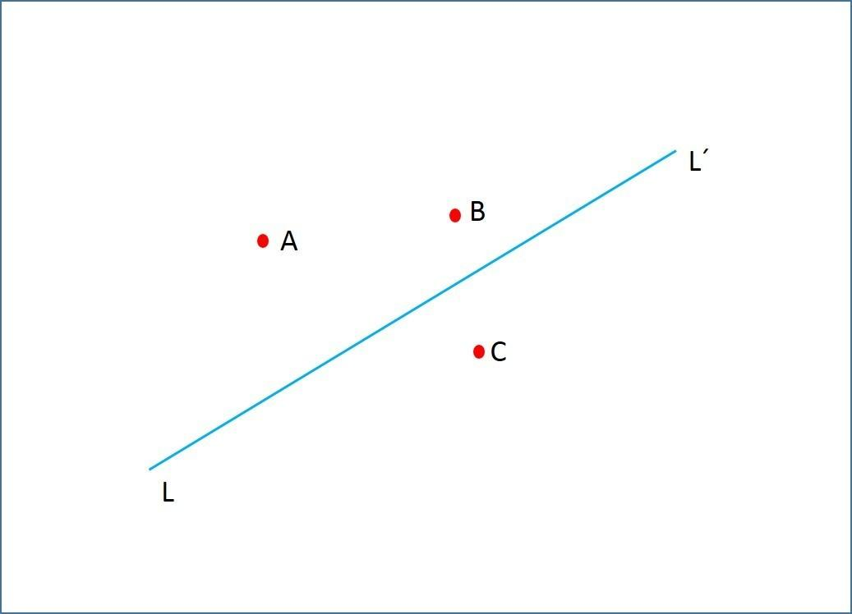
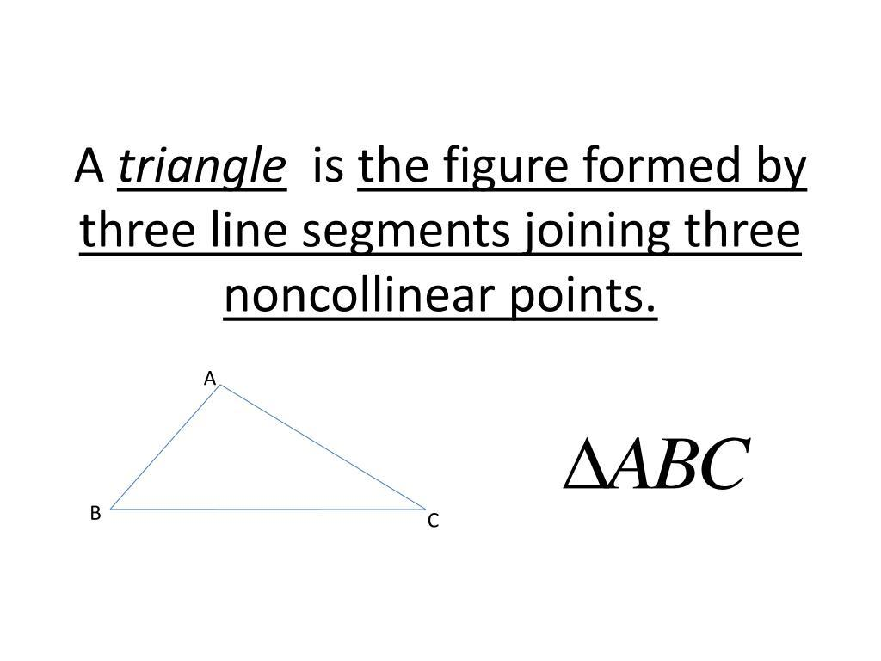
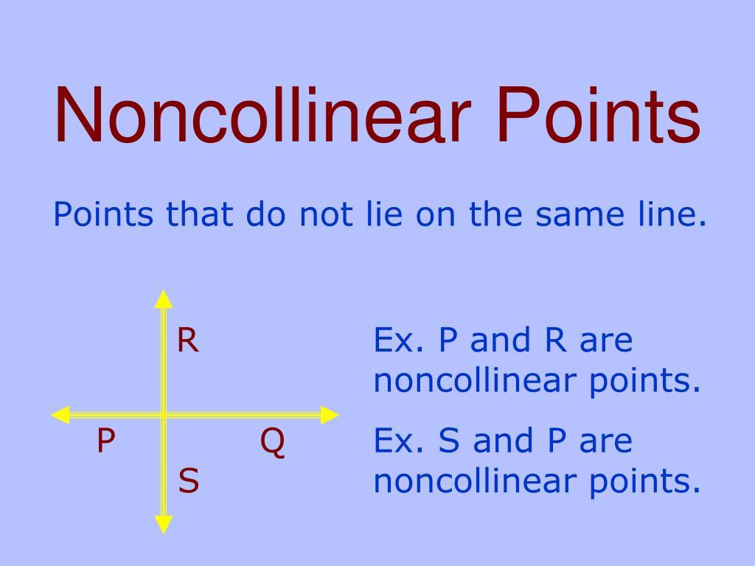
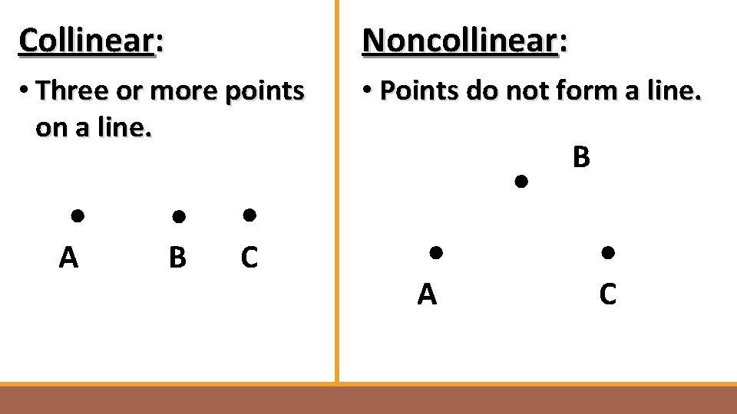

Definition
# Source: AI Source: Provided by: [Data Path: Persons Table -> ID Column: 1, Name_En Column: Motasem Essam] -> From: [ChatGPT] on [7/25/2026]
Non-Collinear Points are two or more points that do not all lie on the same straight line. If no single straight line can pass through all the points simultaneously, they are called non-collinear.
In geometry, three non-collinear points determine a unique plane and can form a triangle.

Characteristics
# Source: AI Source: Provided by: [Data Path: Persons Table -> ID Column: 1, Name_En Column: Motasem Essam] -> From: [ChatGPT] on [7/25/2026]
Non-collinear points:
- Do not lie on one straight line.
- Cannot all be connected by a single line.
- May form geometric figures such as triangles and polygons.
- Determine a unique plane when three points are considered.
- Are independent of orientation (horizontal, vertical, or diagonal).

Illustration
# Source: AI Source: Provided by: [Data Path: Persons Table -> ID Column: 1, Name_En Column: Motasem Essam] -> From: [ChatGPT] on [7/25/2026]
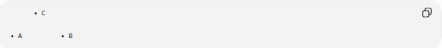
• C

• A • B
Points A, B, and C are non-collinear because they do not lie on the same straight line.

Examples
# Source: AI Source: Provided by: [Data Path: Persons Table -> ID Column: 1, Name_En Column: Motasem Essam] -> From: [ChatGPT] on [7/25/2026]
Three Non-Collinear Points
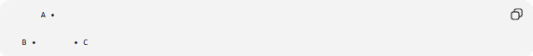
A •

B • • C
No single straight line passes through all three points.

Triangle Formed by Non-Collinear Points
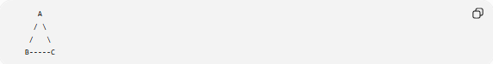
A
/ \
/ \
B-----C
Since A, B, and C are non-collinear, they form a triangle.

Mathematical Representation
# Source: AI Source: Provided by: [Data Path: Persons Table -> ID Column: 1, Name_En Column: Motasem Essam] -> From: [ChatGPT] on [7/25/2026]
For points
$$A\left(x_{1} , y_{1}\right), B\left(x_{2} , y_{2}\right), C\left(x_{3} , y_{3}\right)$$
they are non-collinear if:
- The slopes between pairs of points are not all equal, or
- The area of the triangle formed by the three points is greater than zero.

Properties
# Source: AI Source: Provided by: [Data Path: Persons Table -> ID Column: 1, Name_En Column: Motasem Essam] -> From: [ChatGPT] on [7/25/2026]
Non-collinear points:
- Do not belong to the same straight line.
- Can form triangles.
- Determine a unique plane.
- Are essential for constructing most geometric figures.
- May serve as vertices of polygons.

Applications
# Source: AI Source: Provided by: [Data Path: Persons Table -> ID Column: 1, Name_En Column: Motasem Essam] -> From: [ChatGPT] on [7/25/2026]
Non-collinear points are used in:
- Plane Geometry
- Coordinate Geometry
- Engineering
- Surveying
- Architecture
- CAD (Computer-Aided Design)
- Computer Graphics
- GIS (Geographic Information Systems)
- Robotics
- Navigation

Advantages
# Source: AI Source: Provided by: [Data Path: Persons Table -> ID Column: 1, Name_En Column: Motasem Essam] -> From: [ChatGPT] on [7/25/2026]
Studying non-collinear points helps to:
- Construct geometric figures.
- Define planes uniquely.
- Analyze shapes and polygons.
- Support geometric proofs.
- Improve spatial modeling.

Limitations
# Source: AI Source: Provided by: [Data Path: Persons Table -> ID Column: 1, Name_En Column: Motasem Essam] -> From: [ChatGPT] on [7/25/2026]
Non-collinear points:
- Require at least three distinct points for meaningful classification.
- Depend on accurate coordinate measurements in computational applications.

Comparison with Collinear Points
# Source: AI Source: Provided by: [Data Path: Persons Table -> ID Column: 1, Name_En Column: Motasem Essam] -> From: [ChatGPT] on [7/25/2026]
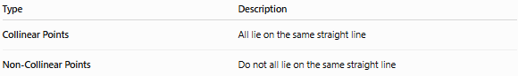
Type | Description
Collinear Points | All lie on the same straight line
Non-Collinear Points | Do not all lie on the same straight line

Key Points
# Source: AI Source: Provided by: [Data Path: Persons Table -> ID Column: 1, Name_En Column: Motasem Essam] -> From: [ChatGPT] on [7/25/2026]
- Non-Collinear Points do not all lie on one straight line.
- Three non-collinear points:
  - Form a triangle.
  - Determine a unique plane.
- They are fundamental for constructing polygons and other geometric figures.
- Non-collinear points are widely used in geometry, engineering, surveying, CAD, GIS, and computer graphics.

Conclusion
# Source: AI Source: Provided by: [Data Path: Persons Table -> ID Column: 1, Name_En Column: Motasem Essam] -> From: [ChatGPT] on [7/25/2026]
Non-Collinear Points are points that cannot all be contained on a single straight line, making them essential for creating two-dimensional geometric figures. Three non-collinear points uniquely define a plane and provide the basis for constructing triangles, polygons, and many other shapes. This concept is fundamental in geometry, engineering, surveying, architecture, CAD, GIS, robotics, navigation, and computer graphics, where accurate spatial relationships and geometric constructions are required.

